Group “Lerdorf” Project Proposal

* Project title
  + Widget Personal Planner
* Team Members
  + Blake Robert
  + Brian Smith
  + Brendon Esperancilla
* Project Description
  + Widget board for organizational aid
  + Modular, can add additional functionality by adding additional widgets
* Sketch of final Product or Framework:
  + Index.html
  + 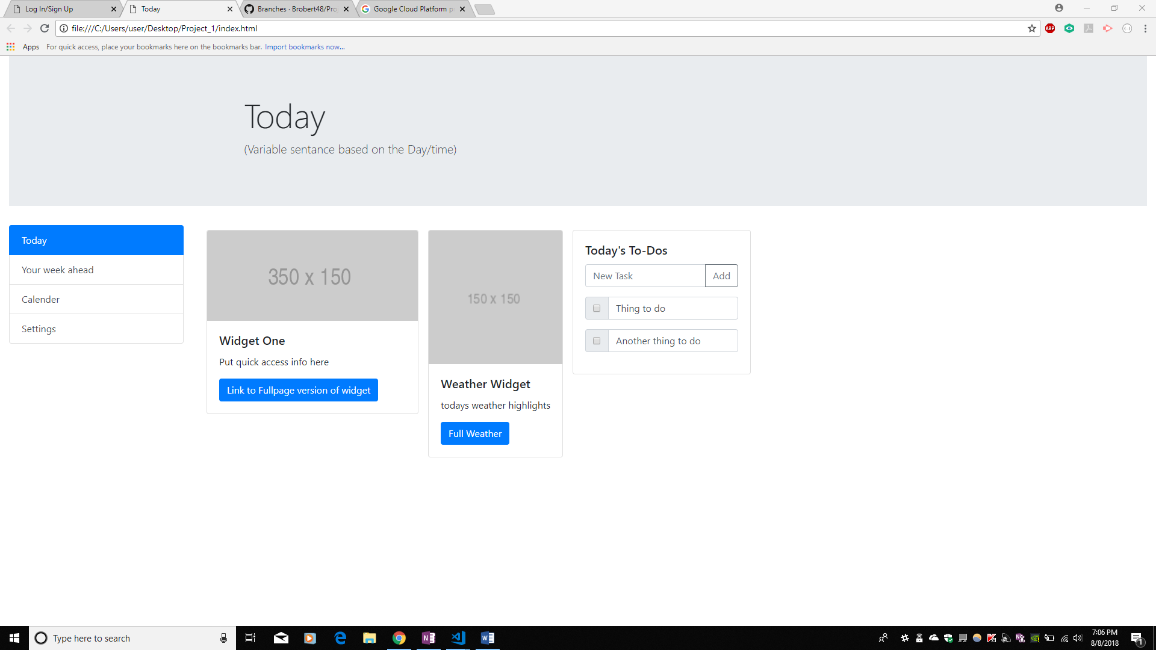

High-level ambition:

Facial recognition login

More widgets here

* + Login.html
  + 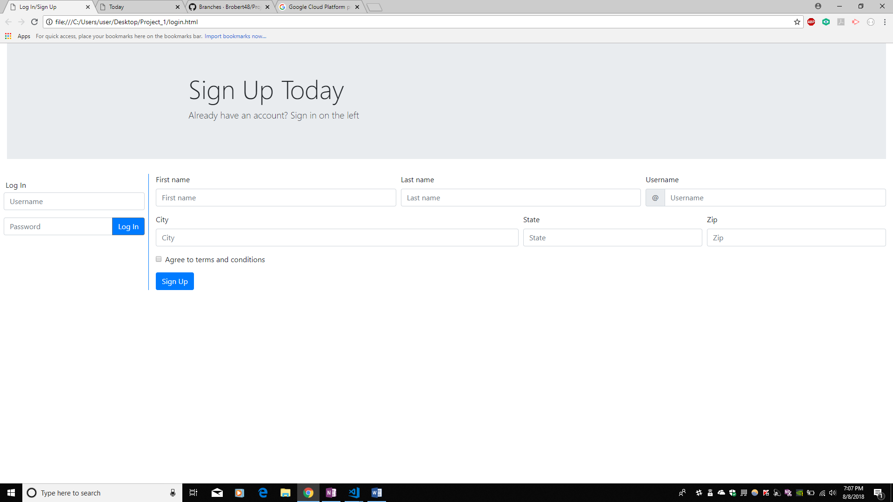
* APIs
  + Weather
  + Horoscope
  + Traffic
  + Others
* Intended audience/user
  + Literally anybody, but aim for those on a schedule
  + Students
  + Commuters
* Rough Breakdown of Tasks
  + Program Front End User Interface
  + Link APIs
  + Link pages to Firebase
  + Program individual widgets